# **BANK LOAN /QUEARY DOCUMENT**

# Bank Loan Report

Kpi,s:

**Total Loan Application:**

SELECT COUNT(id) AS TOTAL_LOAN_APPLICATIONS FROM bank_loan_data



**MONTH TO DATE TOTAL_LOAN_APPLICATION:**

SELECT COUNT(id) AS MTD_TOTAL_LOAN_APPLICATIONS FROM bank_loan_data

WHERE MONTH(issue_date) =12 AND YEAR(issue_date) = 2021



**Total_Funded_Amount:**

SELECT SUM(loan_amount) as total_funded_amount from bank_loan_data

where MONTH(issue_date) = 12 and YEAR(issue_date) = 2021



SELECT SUM(loan_amount) as pmtd_total_funded_amount from bank_loan_data

where MONTH(issue_date) = 11 and YEAR(issue_date) = 2021



# **Total Amount received:**

select sum(total_payment) as total_amount_received from bank_loan_data



# **Month to Date Total Amount received:**

select sum(total_payment) as mtd_total_amount_received from bank_loan_data

where MONTH(issue_date) = 12 and YEAR(issue_date) = 2021



# **Avg_interest_rate:**

select round (AVG(int_rate),4) *100 as avg_interest_rate from bank_loan_data



# **Mtd_Avg_interest_rate:**

select round (AVG(int_rate),4) *100 as pmtd_mtd_avg_interest_rate from bank_loan_data

where month(issue_date) = 11 and year(issue_date) = 2021



# **Avg_of_dti:**

select round(AVG(dti),4) *100 as avg_dti from bank_loan_data



# **Mtd_Avg_of_dti:**

select round(AVG(dti),4) * 100 as mtd_avg_dti from bank_loan_data

where MONTH(issue_date) = 12 and year(issue_date) = 2021



# **PMtd_Avg_of_dti:**

select round(AVG(dti),4) * 100 as pmtd_avg_dti from bank_loan_data

where MONTH(issue_date) = 11 and year(issue_date) = 2021



# **Good_Loan_Percentage:**

select

(count(case when loan_status = 'Fully Paid' or loan_status = 'Current' then id end ) *100)

/

COUNT(id) as Good_Loan_percentage

from bank_loan_data



# **Good_Loan_Application:**

select count(id) as Good_Loan_Application from bank_loan_data

where loan_status = 'Fully Paid' or loan_status = 'Current'



# **Good_Loan_funded_Amount:**

select sum(loan_amount) as good_loan_Funded_Amount from bank_loan_data

where loan_status = 'Fully Paid' or loan_status = 'Current'



# **Good_Loan_received_Amount:**

select sum(total_payment) as good_loan_Received_Amount from bank_loan_data

where loan_status = 'Fully Paid' or loan_status = 'Current'

# **Bad_Loan_Percentage:**

select

(COUNT(case when loan_status = 'Charged off' then id end) *100.0) /

count(id) as bad_loan_percentage

from bank_loan_data



# **Bad_Loan_Application:**

select count(id) as bad_loan_application from bank_loan_data

where loan_status = 'Charged off'



# **Bad_Loan_funded_amount:**

select sum(loan_amount) as bad_loan_funde_Amount from bank_loan_data

where loan_status = 'Charged off'



# **Bad_Loan_received_amount:**

select sum(total_payment) as bad_loan_amount_received from bank_loan_data

where loan_status = 'Charged off'



select

loan_status,

COUNT(id) as Total_loan_application,

SUM(total_payment) as total_amount_received,

SUM(loan_amount) as total_funded_amount,

AVG(int_rate * 100) as interest_rate,

AVG(dti *100) aS DTI

FROM

bank_loan_data

GROUP by

loan_status

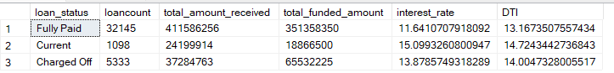

SELECT

loan_status,

SUM(total_payment) as mtd_total_amount_received,

SUM(loan_amount) as mtd_totam_funded_amount

from bank_loan_data

where month(issue_date) = 12

group by loan_status

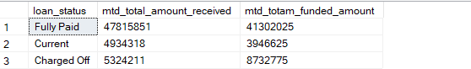

# Month

select

MONTH(issue_date) as month_number,

datename(MONTH,issue_date) as month_name,

COUNT(id) as total_loan_Application,

sum(loan_amount) as total_funded_amount,

sum(total_payment) as total_received_amount

from bank_loan_data

group by DATENAME(MONTH,issue_date), MONTH(issue_date)

order by MONTH(issue_date)

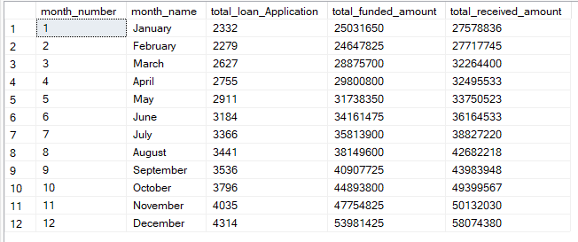

# Address_date:

select

address_state,

COUNT(id) as total_loan_Application,

sum(loan_amount) as total_funded_amount,

sum(total_payment) as total_received_amount

from bank_loan_data

group by address_state

order by address_state

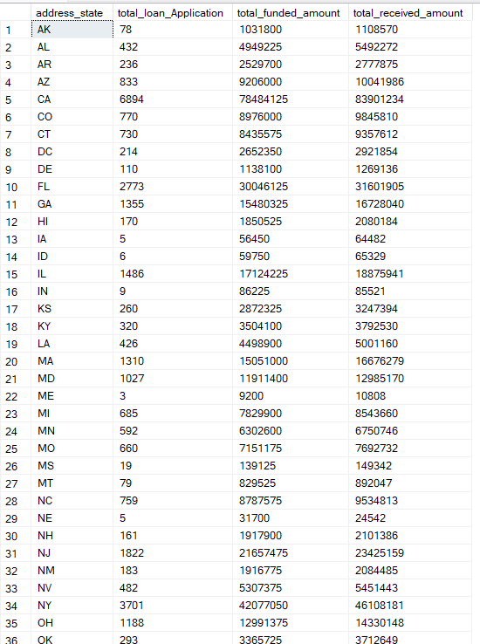

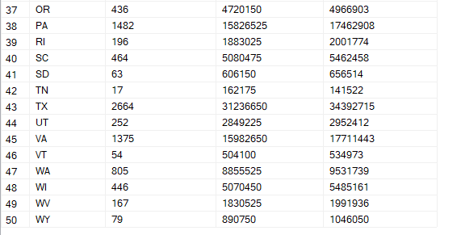

# Month by desc order:

select

address_state,

count(id) as total_loan_Application,

SUM(loan_amount) as total_funded_amount,

SUM(total_payment) as total_received_amount

from bank_loan_data

group by address_state

order by count(id) desc

# term:

select

term,

count(id) as total_loan_Application,

SUM(loan_amount) as total_funded_amount,

SUM(total_payment) as total_received_amount

from bank_loan_data

group by term

order by term



# Respect to the employee lenth:

select

emp_length,

count(id) as total_loan_Application,

SUM(loan_amount) as total_funded_amount,

SUM(total_payment) as total_received_amount

from bank_loan_data

group by emp_length

order by emp_length

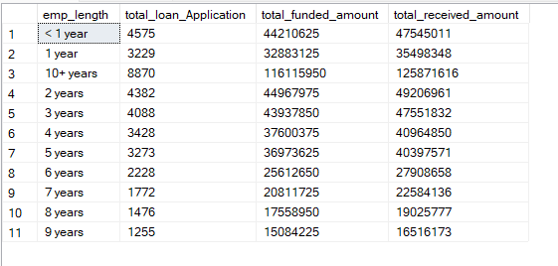

# purpose:

select

purpose,

count(id) as total_loan_Application,

SUM(loan_amount) as total_funded_amount,

SUM(total_payment) as total_received_amount

from bank_loan_data

group by purpose

order by purpose

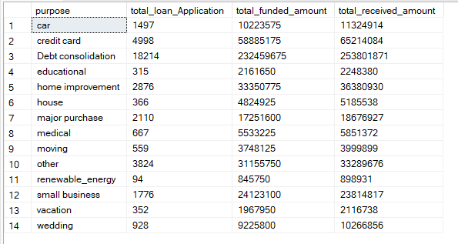

# purpose:

# decenting oder:

select

purpose,

count(id) as total_loan_Application,

SUM(loan_amount) as total_funded_amount,

SUM(total_payment) as total_received_amount

from bank_loan_data

group by purpose

order by COUNT(id) desc

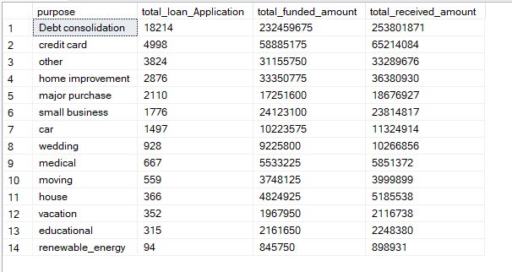

# Loan by home ownership:

select

home_ownership,

count(id) as total_loan_Application,

SUM(loan_amount) as total_funded_amount,

SUM(total_payment) as total_received_amount

from bank_loan_data

group by home_ownership

order by COUNT(id) desc

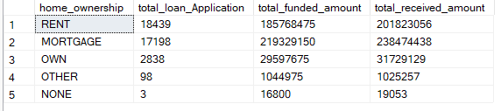

# By Grade And Address State:

select

home_ownership,

count(id) as total_loan_Application,

SUM(loan_amount) as total_funded_amount,

SUM(total_payment) as total_received_amount

from bank_loan_data

where grade = 'A' and address_state = 'CA'

group by home_ownership

order by COUNT(id) desc

